Particle Sample Submission Form
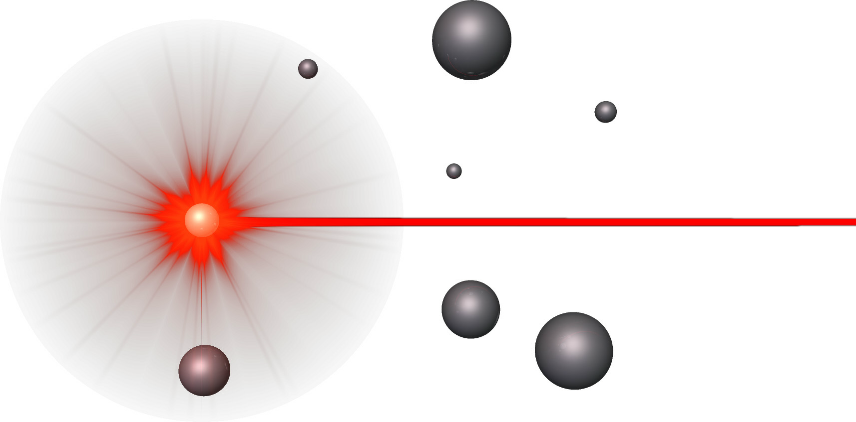
Characterization Laboratories, Inc.

PLEASE SIGN FORM AND INCLUDE YOUR PURCHASE ORDER OR PROCARD NUMBER WITH SAMPLES

COMPANY:
Invoice Contact: |  |  | Shipping Instructions  Please ship samples to:  Particle Characterization Laboratories, Inc.  845 Olive Avenue  Novato, CA 94945  Phone (415) 893-1113; Fax (415) 893-893-0132  Important: Please ship via. FedEx, UPS, DHL, California Overnight, or other carrier that allows for electronic tracking of the package. Please e-mail us the tracking number at sales@particleanalysis.com.
Address:
City, State, ZIP:
E-mail:
Phone:
Fax:
Quote#:
 | (if applicable)
PO/Credit Card#: |  |  | Signature:
Card Exp. Date: |  |  | Signature:
Card Signature: |  |  | Required

Special Invoice Instructions
Sample Information
SAMPLE TYPE | SAMPLE ID# | # of  SAMPLES | ANALYSIS REQUESTED | CLASSIFICATION:  Normal  Hazardous*  (MSDS Required)  STORAGE:  Ambient  Refrigerator  Freezer  Light Sensitive
PLEASE INCLUDE MSDS WITH SAMPLES WHEN POSSIBLE

Sample Processing Information
SAMPLE PRIORITY STATUS | Standard (e-mail data within 5 business days) |  | Rush not available for all analyses  Please call to inquire  Hardcopies of data will be FedEx Priority Overnight
SAMPLE PRIORITY STATUS | 100% Rush / 100% Surcharge  (e-mail data within 3 business days)
SAMPLE PRIORITY STATUS | cGLP / 100% Surcharge  (e-mail data within 10 business days)
Return Samples? | YES* NO | Additional $35 min. fee (FedEx Ground)  *MSDS Required for Hazardous samples–additional shipping charges may apply

